Ideation Phase
Brainstorm & Idea Prioritization Template

Date | 17 February 2026
Team ID | LTVIP2026TMIDS78778
Project Name | Gemini Historical Artifact Description
Maximum Marks | 4 Marks
Brainstorm & Idea Prioritization Template
This phase focuses on identifying innovative solutions for generating historical artifact descriptions using Generative AI. The team collaborated to analyze user challenges, explore possible AI-based solutions, and prioritize the most effective approach for implementation.

Step-1: Team Gathering, Collaboration and Selection of Problem Statement
The team conducted a collaborative discussion session to analyze the defined customer problem statements.
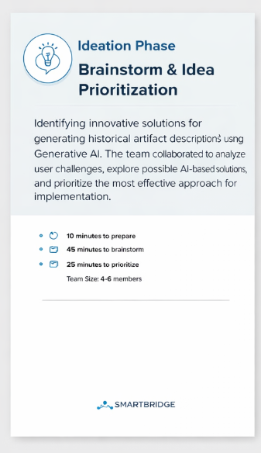

Selected Problem Focus:
Users (historians, students, museum curators, and bloggers) face difficulty in generating accurate, structured, and engaging historical artifact descriptions due to scattered information sources and lack of domain expertise, especially when interpreting artifact images.
Final Selected Direction:
Develop an AI-powered web application using Gemini 1.5 Flash that can:
- Generate detailed artifact descriptions from text input
- Analyze uploaded artifact images
- Provide structured historical context and interesting facts
- Allow customizable word count

Step-2: Brainstorm, Idea Listing and Grouping
During brainstorming, the team listed all possible solution ideas without filtering them initially.
Idea List:
- AI-based historical artifact description generator
- Image-based artifact recognition and contextual description
- Automatic generation of historical facts section
- Word count customization feature
- Multi-language support for artifact descriptions
- Export generated content as PDF or text file
- Artifact comparison feature (compare two artifacts)
- Integration with historical timeline visualization
- Voice input for artifact description request
- Cloud-based deployment using Streamlit
Idea Grouping:
Group 1: Core AI Features
- Text-based artifact description
- Image-based artifact analysis
- Interesting historical fact generation
Group 2: User Experience Enhancements
- Word count customization
- Content export option
- Simple and interactive UI
Group 3: Advanced/Future Enhancements
- Multi-language support
- Timeline visualization
- Artifact comparison feature
- Voice-based input
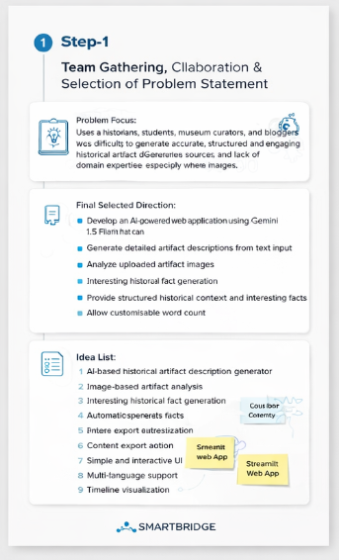

Step-3: Idea Prioritization
The team evaluated ideas based on:
- Feasibility within project timeline
- Technical complexity
- Alignment with problem statement
- Impact on user experience
High Priority (Implemented in Current Project):
- Text-based artifact description generation
- Image-based artifact description using Gemini 1.5 Flash
- Interesting historical facts section
- Word count customization
- Streamlit-based web interface
Medium Priority (Future Enhancement):
- Content export functionality
- Multi-language support
Low Priority (Future Expansion):
- Artifact comparison feature
- Timeline visualization
- Voice input support
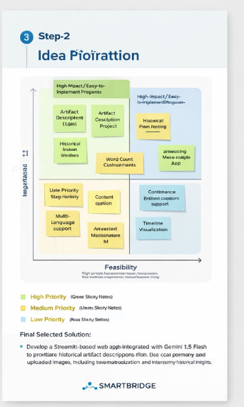
Final Selected Solution:
Develop a Streamlit-based web application integrated with Gemini 1.5 Flash that generates detailed historical artifact descriptions from both text prompts and uploaded images, including structured content and interesting historical insights.

